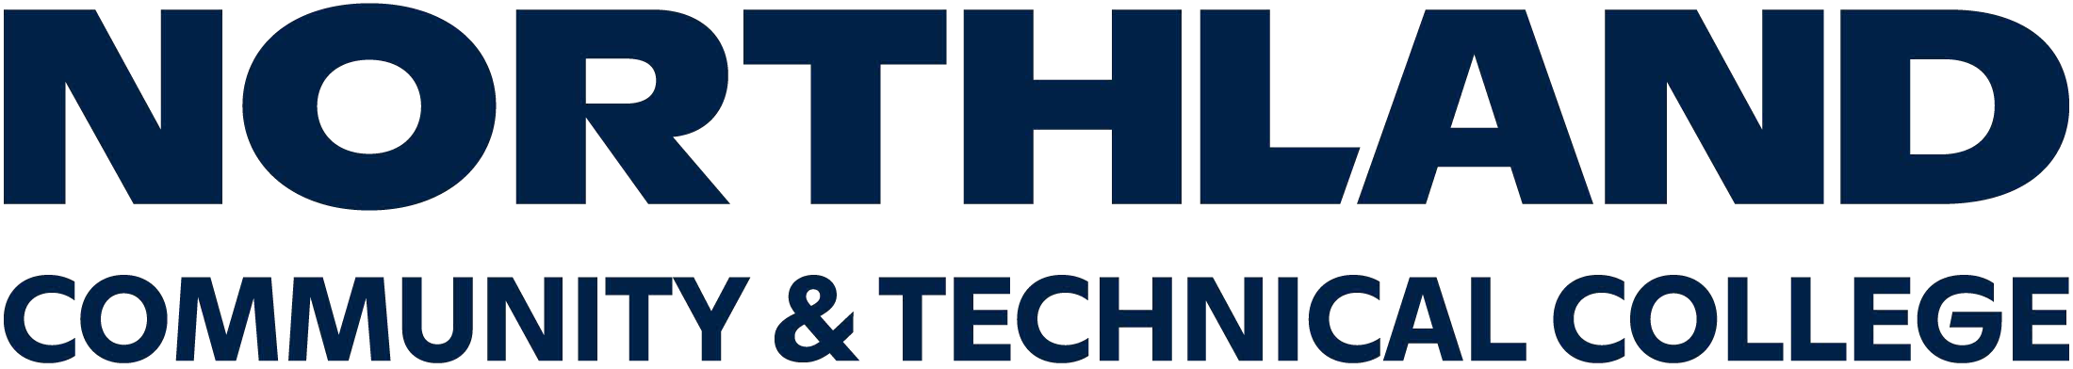

# WAIVER OF LIABILITY, ASSUMPTION OF RISK,

**AND INDEMNITY AGREEMENT – ON/OFF CAMPUS ACTIVITIES**

**Waiver**: In consideration of being permitted to participate in the

(Program/Activity), I, for myself, my heirs, personal representatives or assigns, **do hereby release, waive, and discharge** Northland Community & Technical College, Minnesota State Colleges and Universities, the State of Minnesota and their officers, employees, agents, successors and assigns from liability **for any and all claims, demands, actions, causes of action, judgments, damages, expenses and costs, (including attorney fees)** due to negligence or accidentally resulting in personal injury or illness (including death), and property loss which arise out of, result from, occur during, or are connected in any manner with my participation in the Program/Activity.

**Assumption of Risk**: Participation in the Program/Activity carries with it certain risks that cannot be eliminated regardless of the care taken to avoid injuries. The specific risks vary from one activity to another and include but are not limited to 1) minor injuries such as scratches, bruises, and sprains; 2) major injuries such as eye injury or loss of sight, joint or back injuries, heart attacks, and concussions; and 3) catastrophic injuries including paralysis and death.

# I have read the previous paragraphs and I know, understand, and appreciate these and other inherent risks. I hereby assert that my participation is voluntary and I knowingly assume all such risks.

**Indemnification and Hold Harmless**: I also agree to INDEMNIFY AND HOLD HARMLESS Northland Community & Technical College, Minnesota State Colleges and Universities, the State of Minnesota and their officers, employees, and agents from any and all claims, actions, suits, procedures, costs, expenses, damages and

liabilities, including attorney’s fees which arise out of, result from, occur during, or are connected in any manner with my participation in the Program/Activity.

**Severability**: The undersigned further expressly agrees that the foregoing waiver and assumed risk agreement is intended to be as broad and inclusive as is permitted by the Laws of the State of Minnesota and that if any portion thereof is held invalid, it is agreed that the balance shall, notwithstanding, continue in full legal force and effect.

**Acknowledgment of Understanding**: I have read this waiver of liability, assumption of risk and indemnity agreement, fully understand its terms, and **understand that I am giving up my rights, including my right to sue**. I acknowledge that I am signing the agreement freely and voluntarily, and **intend by my signature to be a complete and unconditional release of liability** to the greatest extent allowed by law.

Print Name Star ID Student ID (Required)

Sign Name Date

Signature of parent/guardian (if student is under the age of 18):