- The ATI TEAS® is available in proctored computer labs on the EGF and TRF Northland Community and Technical College (NCTC) campus. Applicants are allowed to take the ATI TEAS® once per semester. You must ‘Create an account at www.atitesting.com prior to scheduling. If you haven’t already created an account, please see instructions on “How to Create a New Account”.
- Registration for the ATI TEAS® is conducted through an on-line registration system located at the ATI Web- site. Students will need to register themselves to make their appointment through the ATI website.
- Students must achieve a minimum Adjusted Individual Total Score of 50% to be considered for eligibility to en- ter PNSG practical Nursing courses. Guidelines for determination of program eligibility, including the interpre- tation of ATI TEAS® exam scores, are subject to change.


EFFECTIVE MARCH 1, 2025: ALL TEAS EXAMS MUST BE COMPLETED IN-PERSON

AT AN APPROVED COLLEGE TESTING CENTER.
Click on ‘Online Store’ at the top of the page.
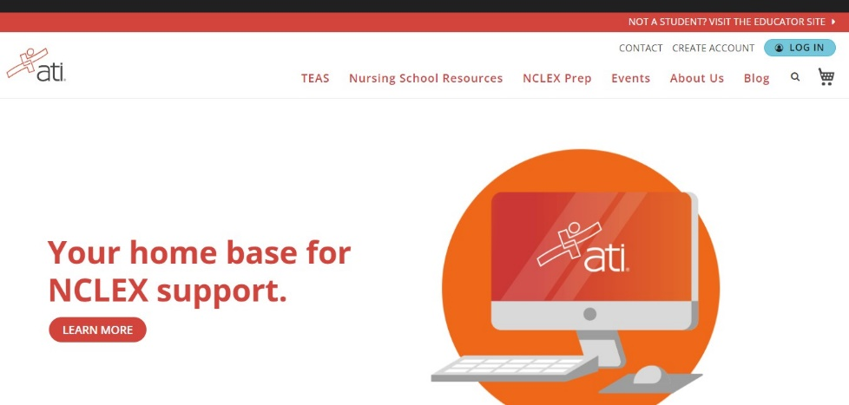
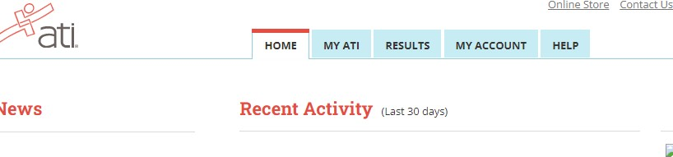
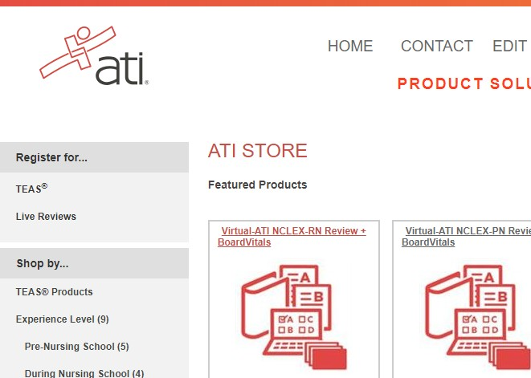
LOG IN to your account at
www.atitesting.com
ister for ‘TEAS®’ on the left side of the page.
Reg
*DO NOT SELECT:
‘Register for TEAS with PSI’.
This is not for the EGF or TRF main testing centers, and it may cost more.

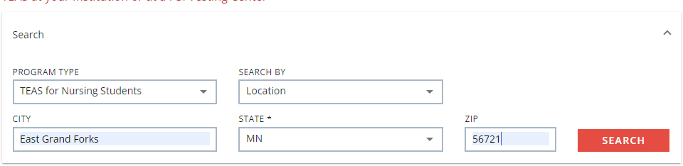

Choose the following from the drop down menus:
Program Type: TEAS for Nursing Students (The ATI TEAS® for Allied Health AH is NOT for nursing students)
Search By: Location
City: East Grand Forks, or Thief River Falls
State: Minnesota
Zip Code: 56721, or 56701 for Thief River Falls
Click ‘Search’ when finished

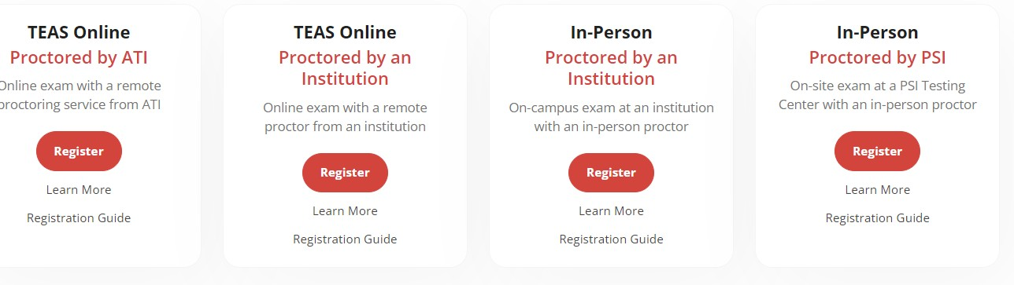
Select: Register for the ‘In-Person Proctored by an Institution’ if you wish to take the exam at an NCTC Test Center.

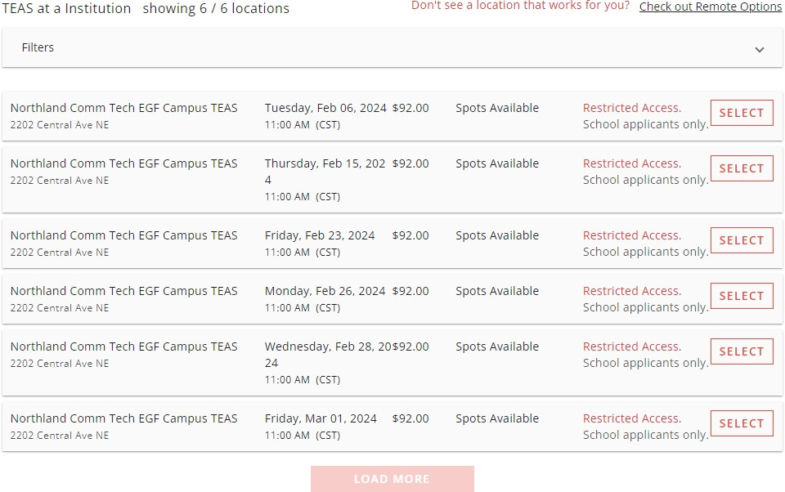
Look through the
dates and times before making your final
registration selection. Remember, once an exam date is chosen, it is final.

Choose ‘Select’ when you have chosen a
date.
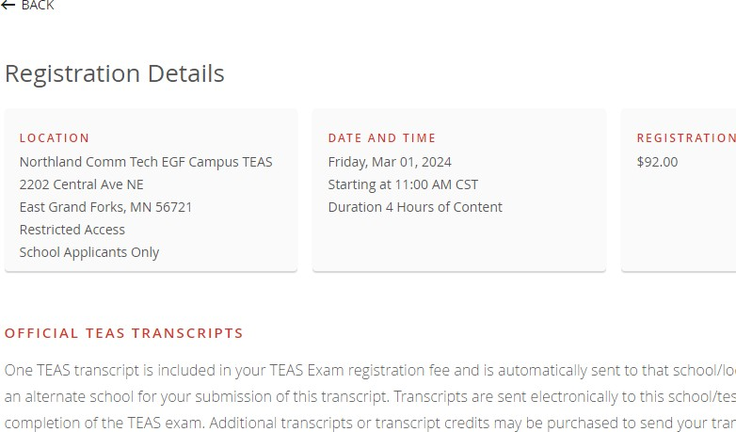
Review your ‘Registration Details’ and scroll down to read through all of the
information listed.

Select ‘Continue Registration’ at the
bottom of the screen.

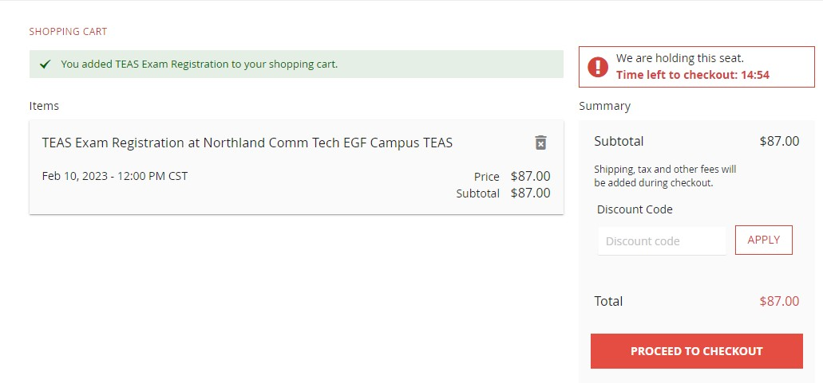
Proceed to Checkout

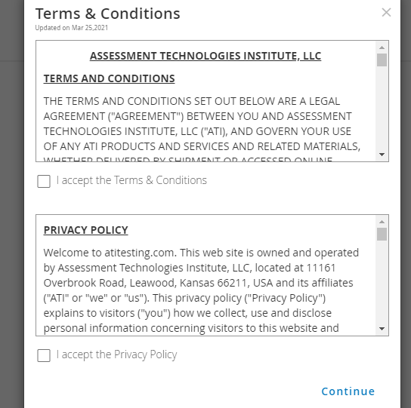
Terms and Conditions
Select ‘Continue’ after reading and accepting the terms and conditions and privacy policy.
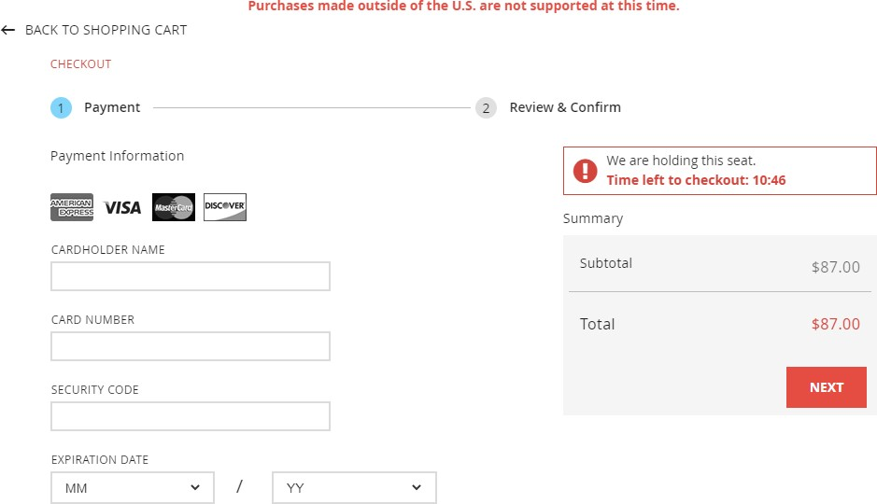
Proceed to Check Out: You will need your Debit/Credit card. Fill out all the required information, including the ATI Purchase Policy.

*Once your order has been submitted, it is non-cancellable and no returns, refunds or credits are available for this
purchase.
You will receive a confirmation letter after you submit your order, read through it carefully.
- Students must bring a picture ID that includes a signature (example: driver license), the log-in and password that the candidate has created when registering with ATI, and arrive at the testing center at least 15 minutes prior to the start of the
scheduled exam time. Calculator is provided on the exam. Do NOT bring your own calculator. Scratch paper and pencil is provided.
- The ATI TEAS is a computer-based 3.5-hour test that measures skills in academic areas of reading, mathematics, science, and English/language usage. The exam is 209 minutes/170 questions
- This exam is 209 minutes/170 questions. Please plan for 4 hours. Content breakdown:
Reading: 55 minutes /45 questions Math: 57 minutes /38 questions Science: 60 minutes /50 questions
English and Language Usage: 37 minutes /37 questions

- VERY IMPORTANT: Please check your email and our college website (www.northlandcollege.edu) for
notifications in the event of inclement weather and poor travel conditions the night before and early morning of the scheduled exam of possible college cancellation. If we need to reschedule, you will be notified.

