**HOW TO CREATE A NEW ACCOUNT**

If you are not a current user on [www.atitesting.com,](http://www.atitesting.com/) you must create a new account to access the student

portal or to make a purchase from ATI's online store. Follow the steps below to create a new account.

Go to [www.atitesting.com,](http://www.atitesting.com/)



click **Create Account**

Enter your information in the following required fields.

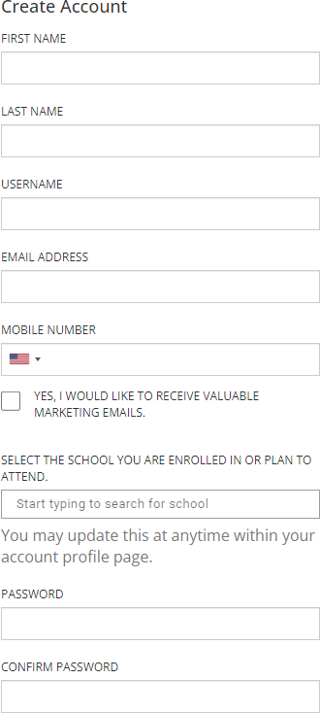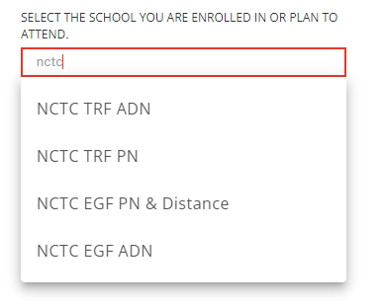

**IMPORTANT: You will need to remember your username and password in order to login to the exam and for future use.**

Begin typing NCTC-

Select the location of the campus you are applying for:

**NCTC EGF PN & Distance** (for East Grand Forks Campus and Distance)

-OR-

NCTC TRF PN

(for Thief River Falls Campus)

Enter your information in the following

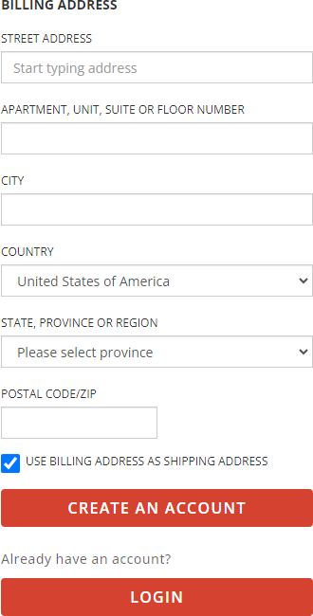

required fields.

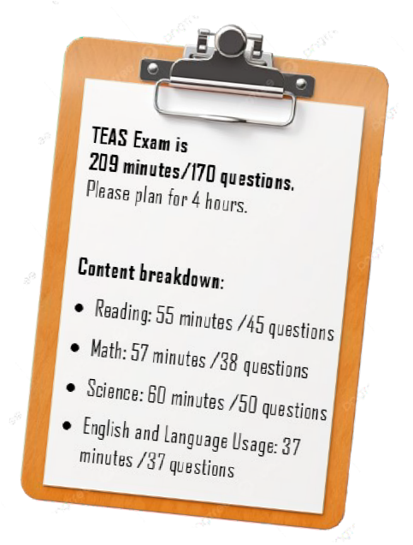

After you have entered all of your information, select: **CREATE AN ACCOUNT**

Terms of Use

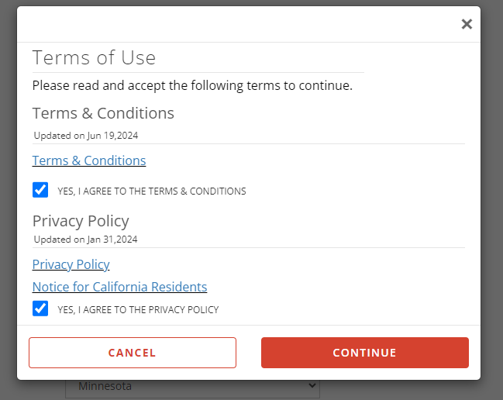

Select CONTINUE after reading and accepting the terms and conditions and privacy policy.

The only field required to fill in is the Expected Graduation Date.

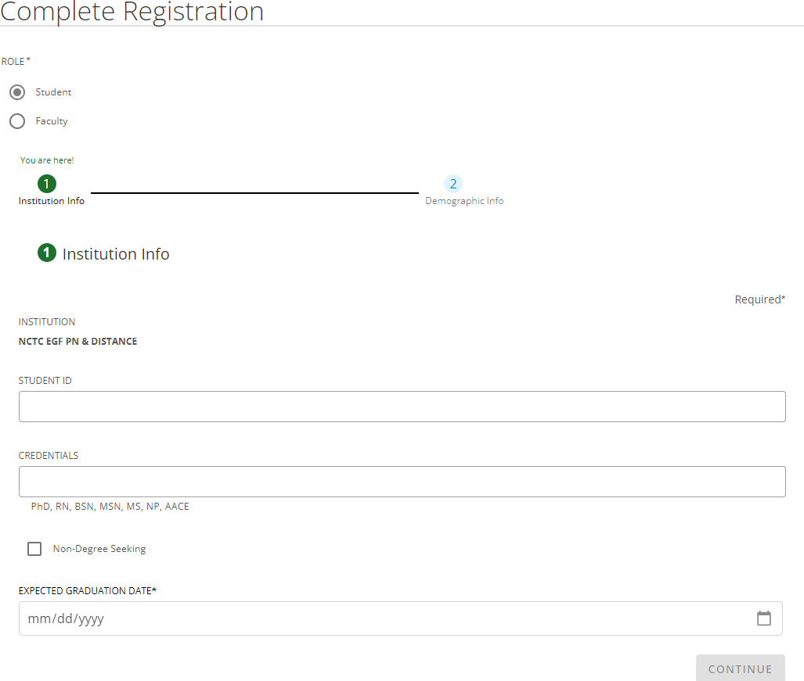

The only field required to fill in is

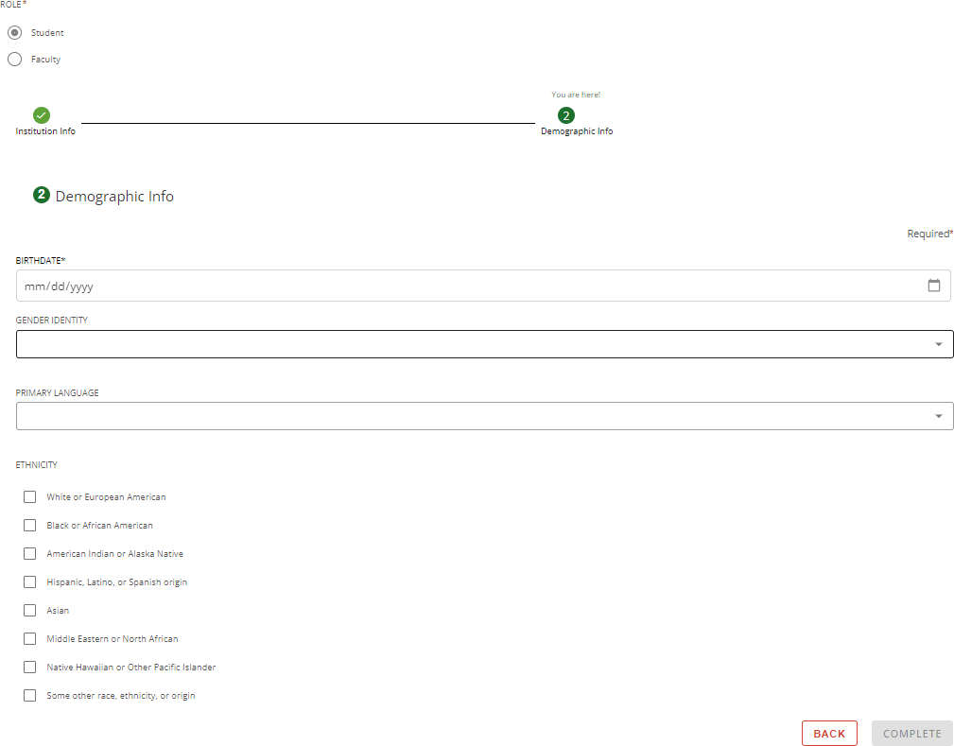

the BIRTHDATE

Select COMPLETE



* **To schedule the ATI TEAS Exam, please follow the handout labeled-**

**‘How to Schedule: In-Person ATI TEAS for Nursing Students**