STUDENT NAME: DATE:


SIGNATURE:
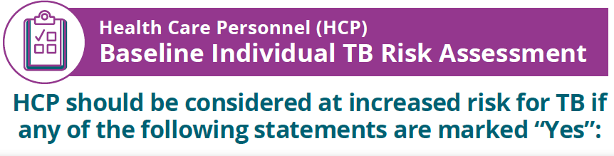

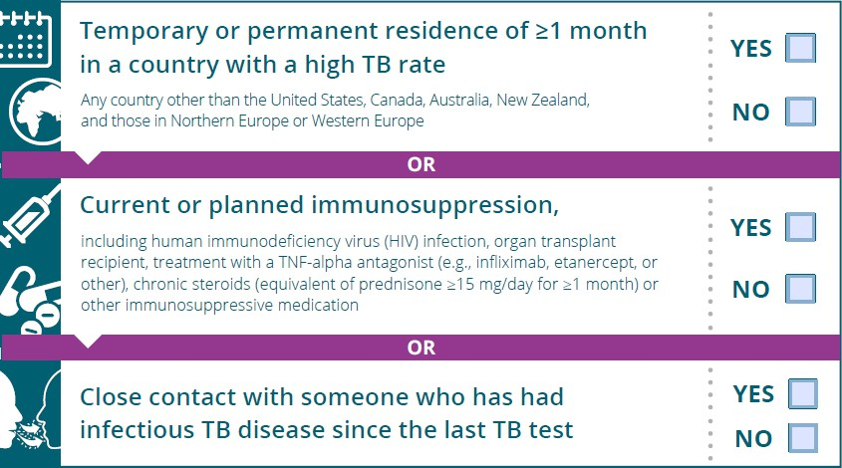
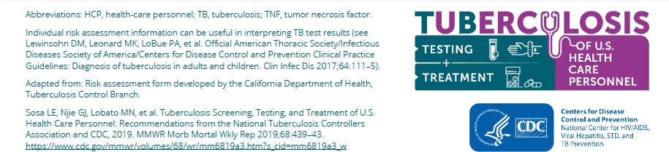
** If any Yes box is checked, or you have a history of Positive TB Testing and /or TB Treatment, you will need an annual letter from a health care provider that states you are medically cleared to provide direct patient care.

